Salmon River Adventures

Site Plan

Anastasiya Yazvinskaya

CIT 230

**Site name:** Salmon River Adventures

**Site purpose:**

Introduce the client to the company and river rafting. Give an opportunity to independently evaluate their capabilities and reserve a place. A site is necessary to attract new customers and facilitate contact with old ones.

**Domain:** www.salmonriveradventures.com

**Icon:**



**Target Audience:**

* Who: Everyone who loves or wants to try a river rafting.
* Age: 18+
* Motivation: The desire to leave the usual urban environment and feel part of the wildю

**Personas:**

* Christine B. Shore
  + Occupation: Chief Operations Officer (COO)
  + Demographics: 45 years old.
  + Motivation: She loves nature and trying something new also she is finding a new way of family trips.
  + Technology: Uses tablet and phone.
* Sahay Kondipali
  + Occupation: Junior Enterprise Solutions Architect
  + Demographics: 35 years old.
  + Motivation: He loves extremal sport.
  + Technology: Uses desktop and phone.

**Scenarios:**

1. I want to try something new and extremal.
2. Where could we go as a family to get even closer to each other?
3. I love river rafting. I wonder what new routes I can visit?
4. I want to try to go rafting on the river and I want to be sure of the professionalism of the company.
5. My friends and I decided to go rafting on the river and this is our first time, so we need the easiest route.

**Color scheme:**

|  |  |
| --- | --- |
| **Element** | **Color** |
| Header | #35d2ab |
| Navigation & Footer | #4282d3 |
| Navigation hover & current | #05326d |

**Typography:**

|  |  |  |  |
| --- | --- | --- | --- |
| **Element** | **Font** | **Size** | **Color** |
| Heading 1 | Pasifico (cursive) | 27px ( - 13px) | #006c51 |
| Heading 2 | Special Elite (cursive) | 35px | #70ed3b |
| Heading 3 | Special Elite (cursive) | 25px | #70ed3b |
| Text | Istok Web (sans-serif) | 16px | #000000 |

**Site map:**

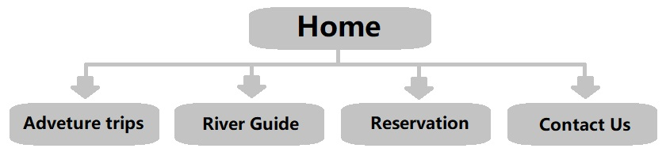

**Wireframe sketches:**

**Desktop view**

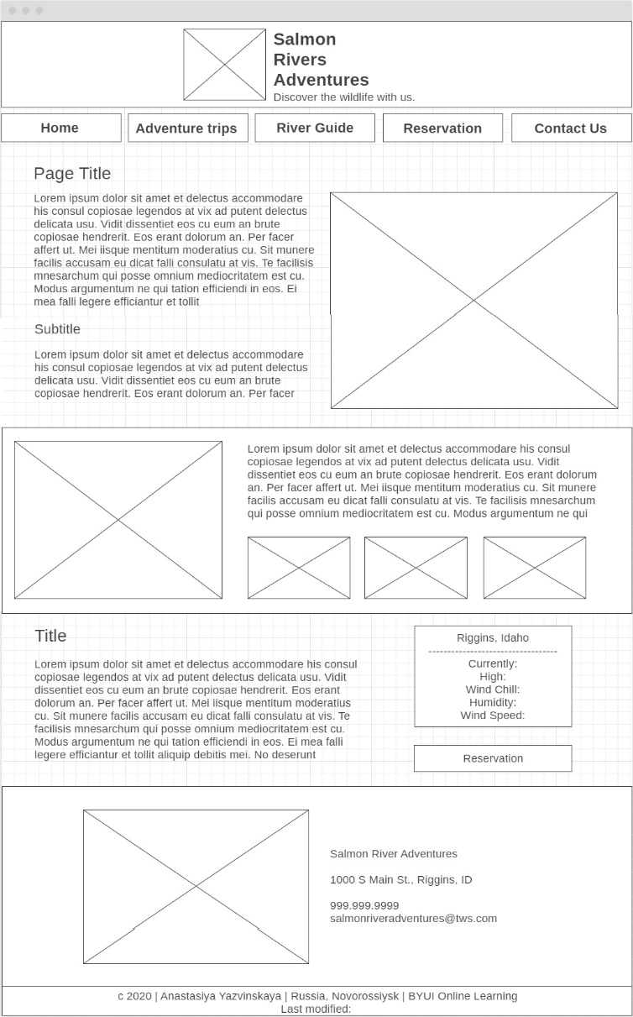

**Laptop view**

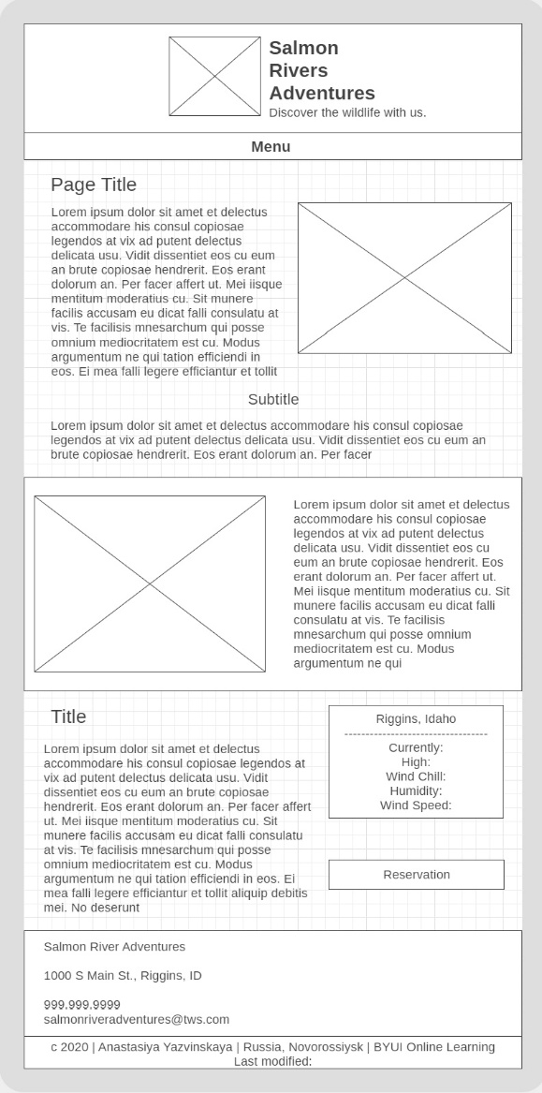

**Phone view**

